USER MANUAL



**Smart Sales Application**

# Table of Contents

1. General Introduction
2. Extensive features of this Sales app
3. System Summary
   1. Hardware and Software Requirement
   2. User Access Levels
4. Steps to Download the Application
5. User Guide
   1. Login
   2. Branch Selection
   3. Dashboard
      1. Team Management
      2. Notification
   4. Contact Person
   5. Customers
   6. Opportunities
   7. Quotations
   8. Orders
   9. Invoices
   10. Inventory
   11. Delivery
   12. Analytics
   13. Calendar
       1. Events
       2. Tasks
   14. Profile

# General Introduction

Cinntra Infotech presents- “Bridge” the best in class sales app for every type of business. Bridge has a complete solution for small to large business organizations. Its fully customizability provides you with endless flexibility to mould it according to your need.

The Bridge Sales App is for small and medium-sized business owners and companies. Being a business owner, you should be well versed with the latest trends and what your competitors are using to grow their business.

Boost collaborative productivity and communicate seamlessly with your team using Bridge

. 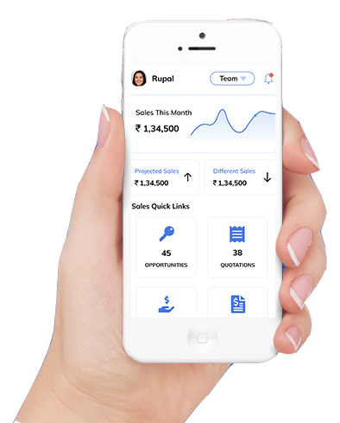

It's fully integrable with any of the Best in class ERP’s connecting all your teams and centralizing the entire communication in one place, giving you more control over your sales and helps you in building a long-term customer relationship.

As it is connected to your back office, it is possible to register new customers, add items from the catalog to the order and have your customers register the order directly on the mobile device. Manually entering sales lists in the back office is a thing of the past for representatives with Bridge Sales App. It is easy and

time-saving.

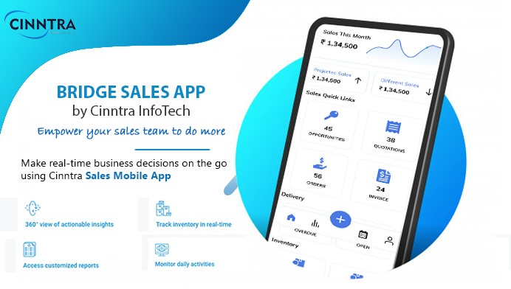

# Extensive features of this Sales app:

Bridge has various practical features that can be used to set up the sales process quickly and easily. Some of them are listed below:

* 1. Ease to setup and configure: Bridge is designed to be easy to use and easy to configure, no need to go through any formal training to use the application.
  2. Integrated with Best in class ERP’s: The application is easily integrable with any of the Best in class ERP’s be it Oracle, SAP, Microsoft.
  3. Work from anywhere: The full power of Bridge is now available from your device. Whether you're in the office, on an airplane, or checking in from a coffee shop, the new Bridge mobile app is your key to productivity. You can work with the Application anywhere on the go.
  4. Better Team Management: Track the progress of your team and have the data bifurcated according to your team. A perfect tool for Managers to understand the work progress and making the entire team aligned.
  5. Analytical Insights: The analytics tool helps you to understand your performance, your business as well as enables you to make critical decisions from anywhere. Get what you need to close deals fasters with your business metrics, helping effortlessly manage your sales process.
  6. Dashboard with 360 degree Overview of the App: The Dashboard gives you 360 degree overview of the App. Easily track lead volume, conversion rates, and every part of your pipeline for a real-time view of the state of your business.
  7. Manage Your Calendar: Maintain and plan your schedule by setting up your events, appointments and reminders. Also, get notified about your events and tasks.
  8. Smart Inventory Tracking: Smartly understand and track your inventory by categorizing the inventory in Fast, Slow and Non moving items, and accordingly make smart sales decisions.
  9. Smart Delivery Tracking: Track the status of the Deliveries and get various delivery related insights. Like: Make Changes to Delivery, Get Comprehensive Order Details and Record Proof of Delivery.
  10. Invoicing & Billing – Manage all your accounting activities i.e. invoicing and billing process.

**Do Less Administration and More Selling**

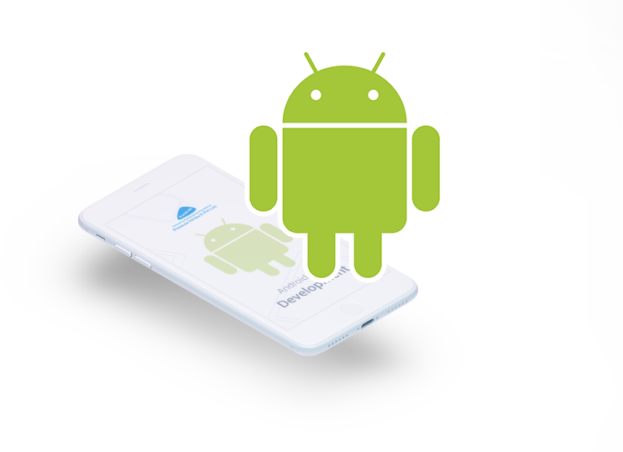

# System Summary

## Hardware and Software Requirements:

* The application is compatible with a smartphone device with Android operating system (OS).
* The minimum Android version should be 4.0.3 and up to avail all the features in the application.
* To unleash the full potential of the application you need a stable internet connection on your device.

## User Access Levels:

The user needs to be registered in the system in order to access the application. Upon receiving the user credentials one can successfully access the application.

Note: There is no demo version for the Guest Users.

# Steps to Download the Application

* 1. The application’s apk can be downloaded from the below link: <https://i.diawi.com/cmb5px>

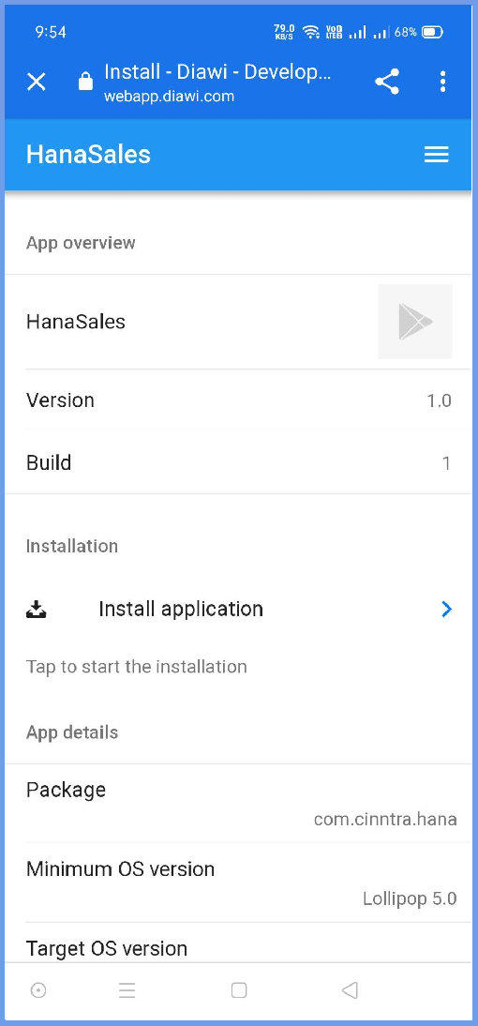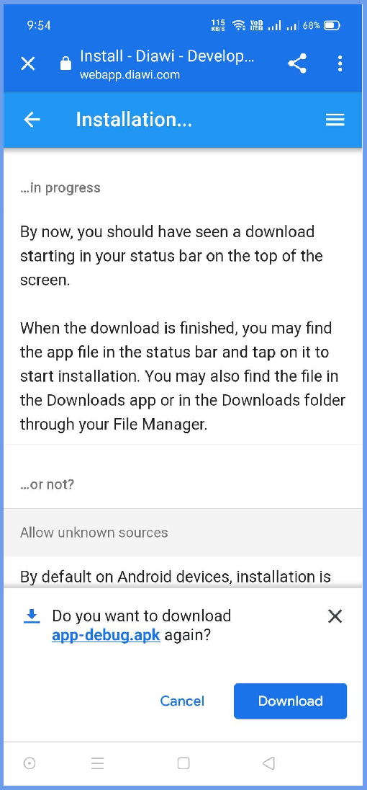

* 1. Once the apk file is downloaded then click on Install.

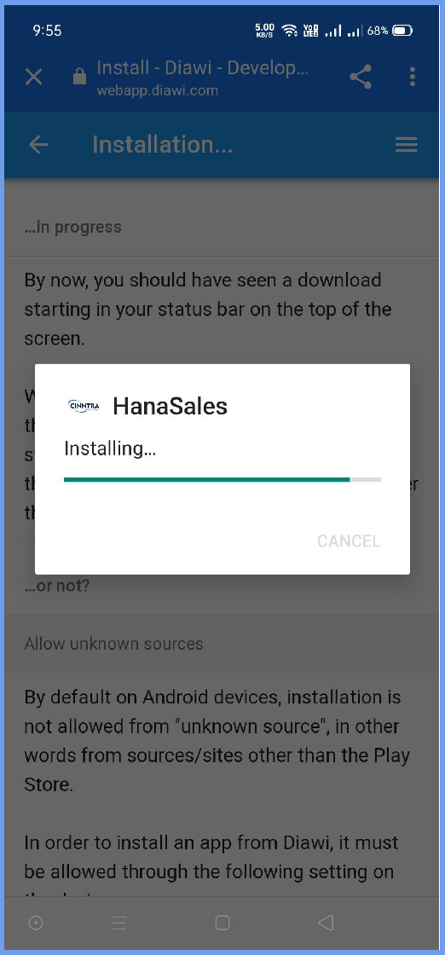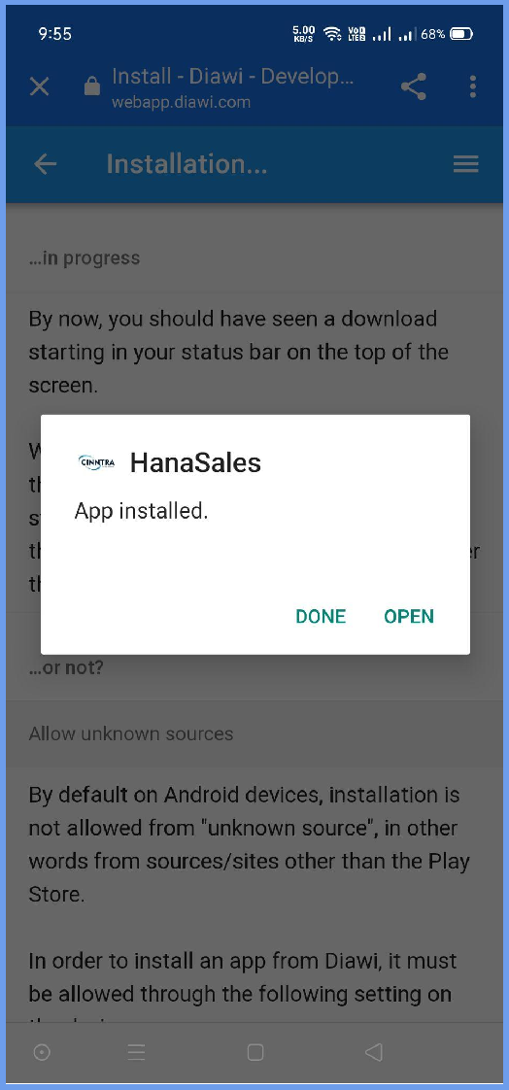

* 1. Enable Unknown Sources Setting in Phone. (It will automatically redirect when installing App )
  2. Once apk installed it will redirect to the Application’s LogIn page.

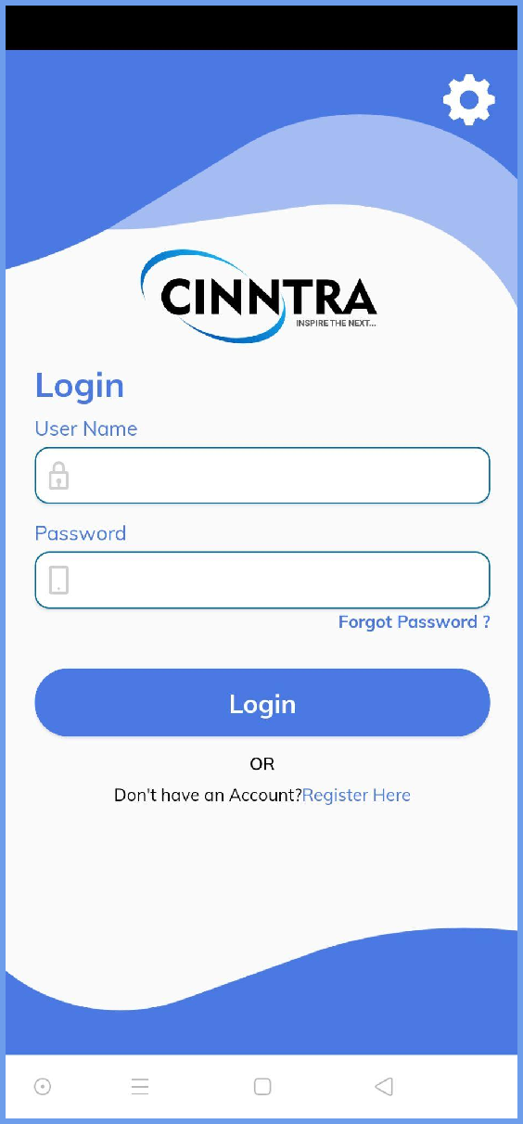

# User Guide

## Login

To sign-in to the application, provide your registered user credentials in the database, and click on the sign-in button.

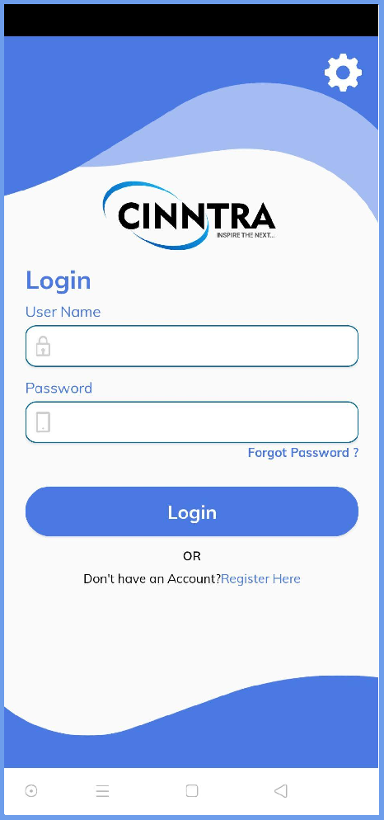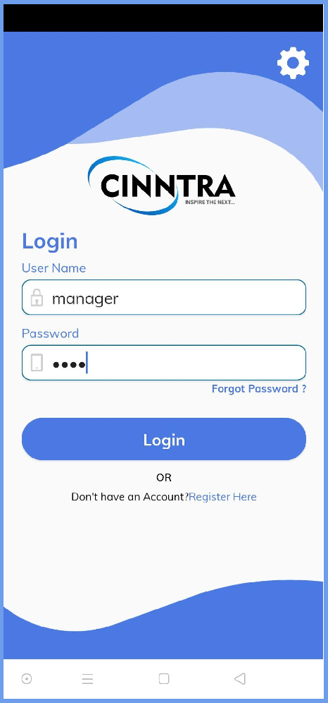

## Branch Selection

Select the branch on which User wants to operate on and configure the data according to the branch.

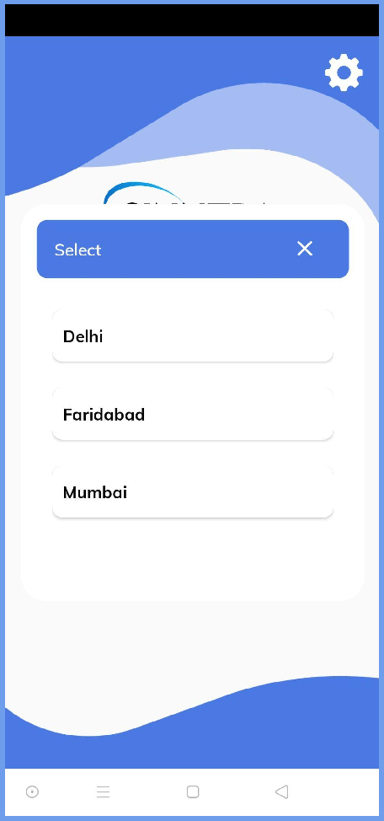

## Dashboard

The Dashboard gives you a 360 degree overview of the App. Easily track lead volume, conversion rates, and every part of your pipeline for a real-time view of the state of your business.

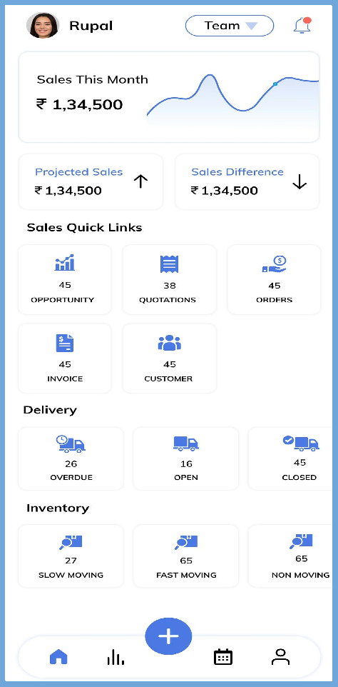

### Team Management

Track the progress of your team and have the data bifurcated according to your team.

After clicking on the Team icon, you will get the list of the Team members who are working under you, you can bifurcate the data after selecting the team member.

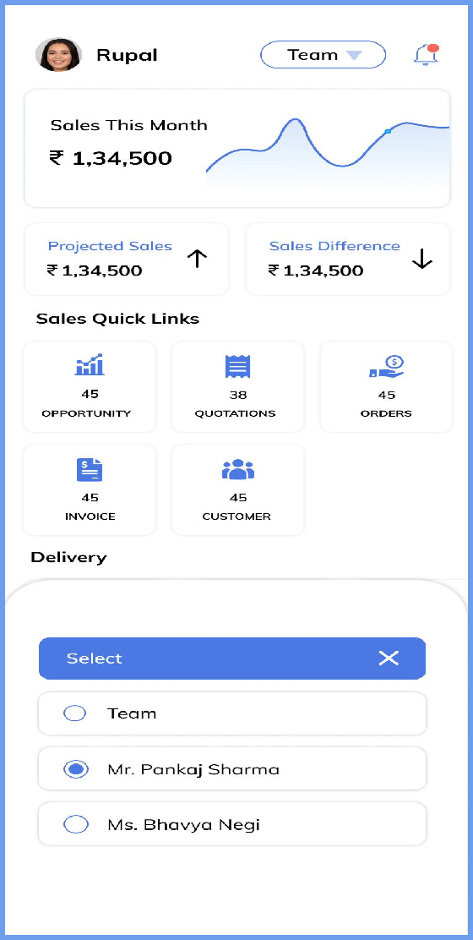

### Notification

Get notified about the recent development happenings in your App. From getting notified about any event happening to any delivery being made.

Get Comprehensive Notifications after clicking on the Notification icon present in the upper right corner.

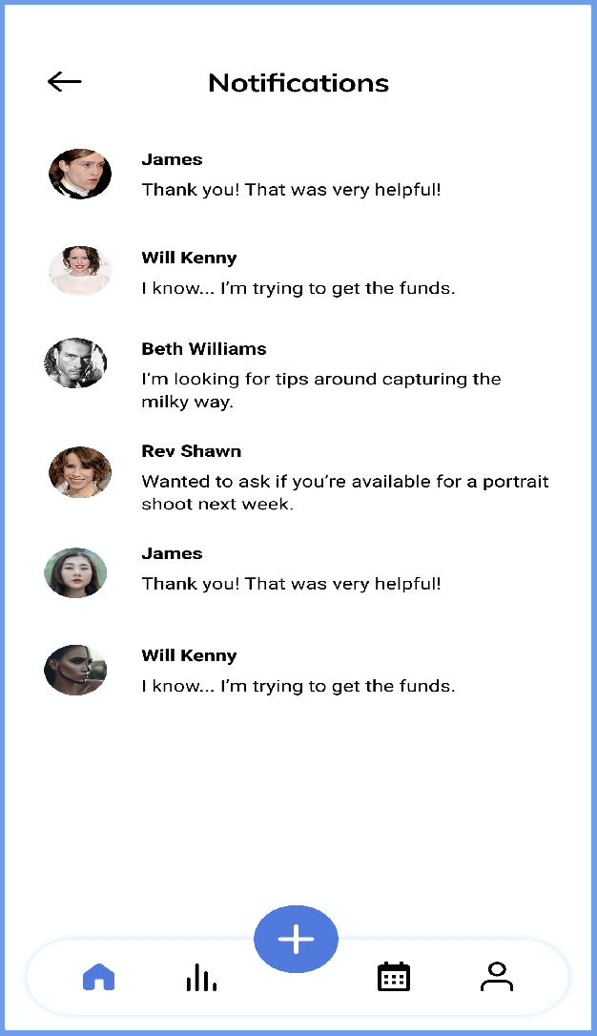

## Contact Person

After clicking on the ‘+’ icon in the bottom center corner, you can add new contacts from the businesses on the go.

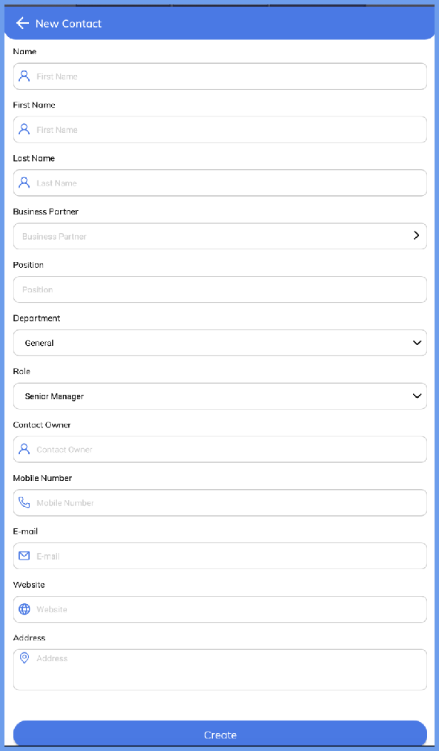

## Customers

#### Viewing Customers:

Click on the customer icon on the dashboard to view the entire list of your customers. After selecting any particular customer view the details of that customer.

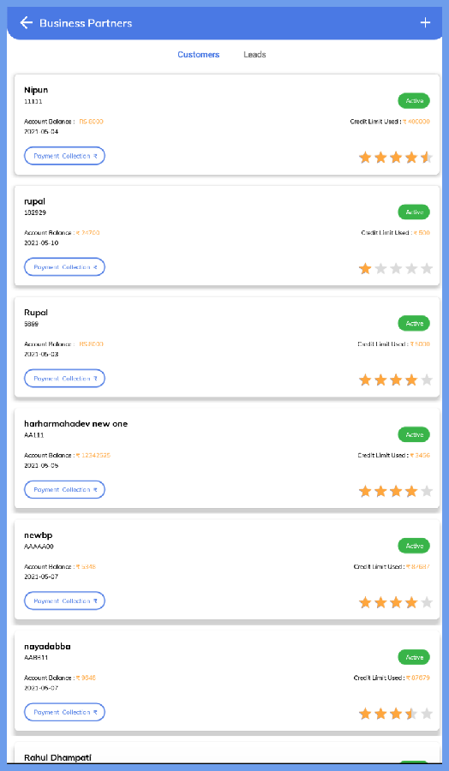The leads can be viewed from clicking on the ‘Leads’ tab from the navigation panel.

#### Creating New Customer:

After entering in the Customer details, click on the ‘+’ icon, it will open the Customer details form, submit the form after filling the necessary details. It will create a new Customer.

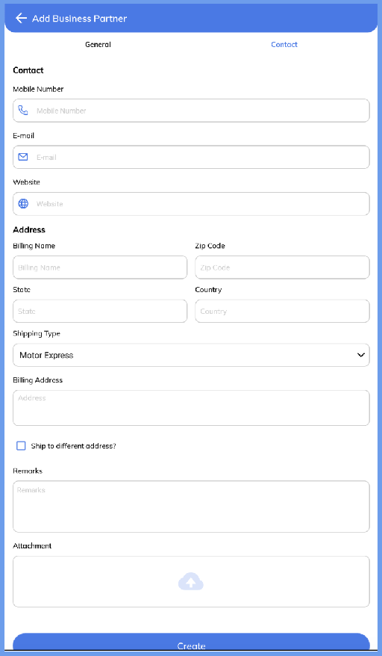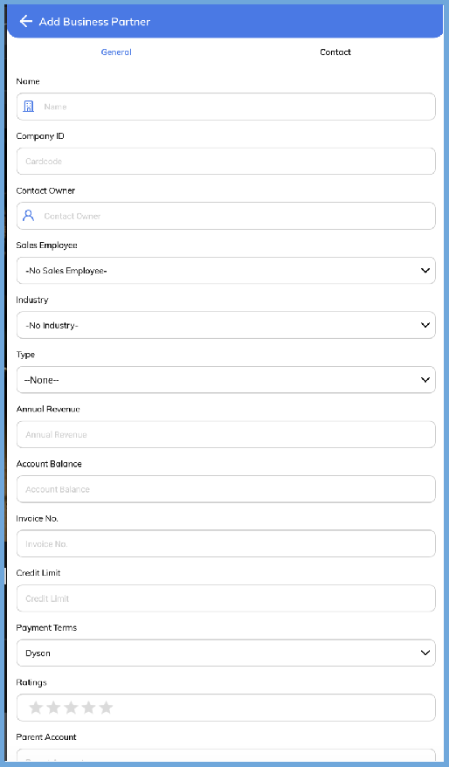

## Opportunities

After clicking on the Opportunities icon on the dashboard, it will open the existing Opportunities.

The Opportunities section is divided in 3 segments: ‘Open’, ‘Won’, ‘Lost’. Click on any of these panels to get Opportunities at different stages.

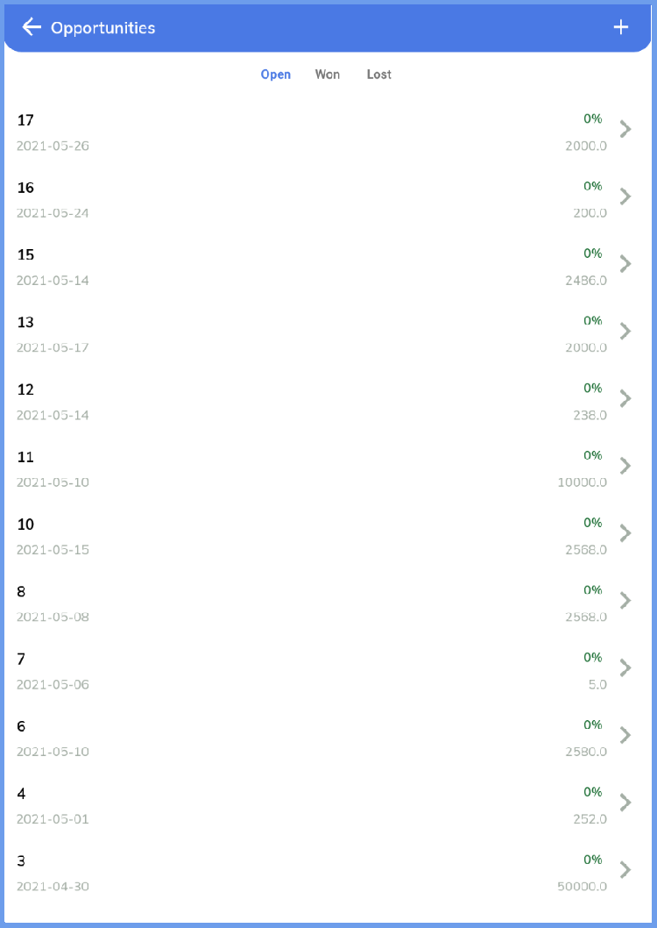

#### View Opportunities

Select any specific opportunity to get more details of the opportunity.

Any details can be updated in the Opportunity by clicking on the pencil icon in the upper right corner.

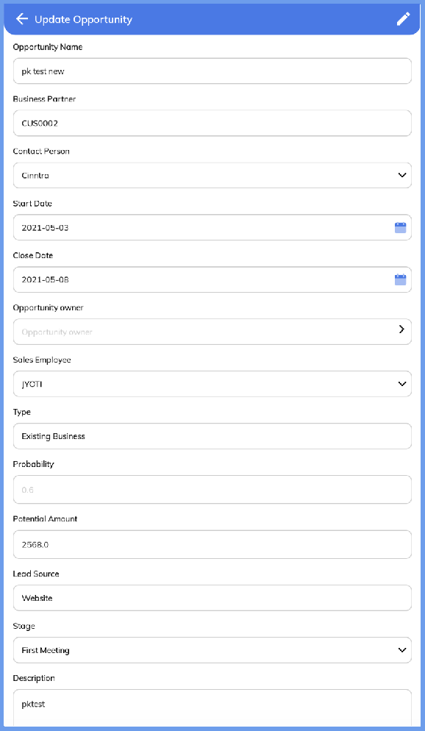

#### Creating New Opportunities

From the landing page of the Opportunities section click on the “+” icon in the upper right corner.

This will open up Opportunities creation form, fill in the necessary details to create a new Opportunity.

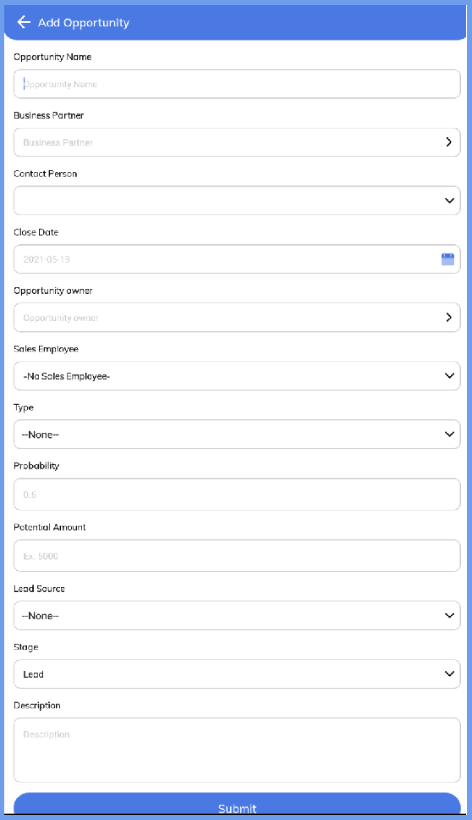

## Quotation

After clicking on the Quotation icon on the dashboard, it will open the existing Quotations.

The Quotation section is divided in 2 segments: ‘Open’, ‘All’.

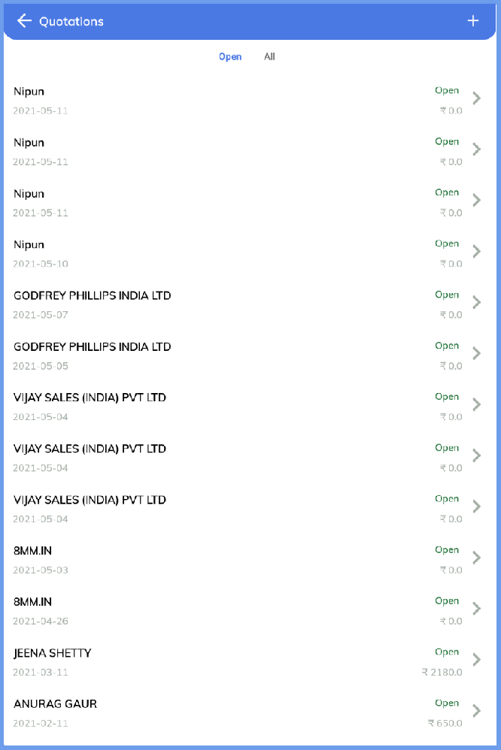

#### View Quotation

Select any specific Quotation to get more details of the Quotation.

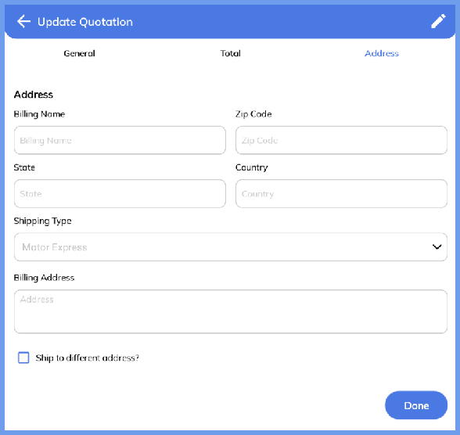Any details can be updated in the Quotation by clicking on the pencil icon in the upper right corner.

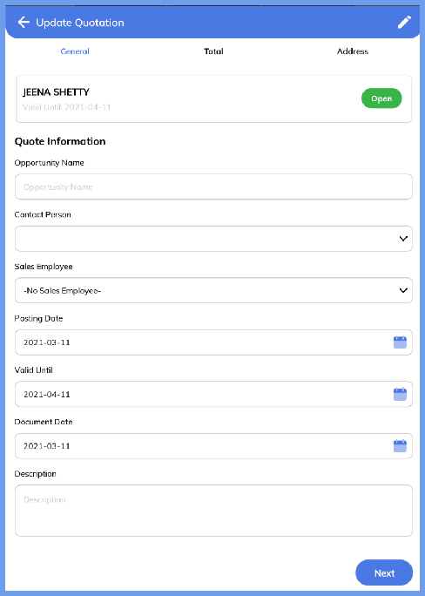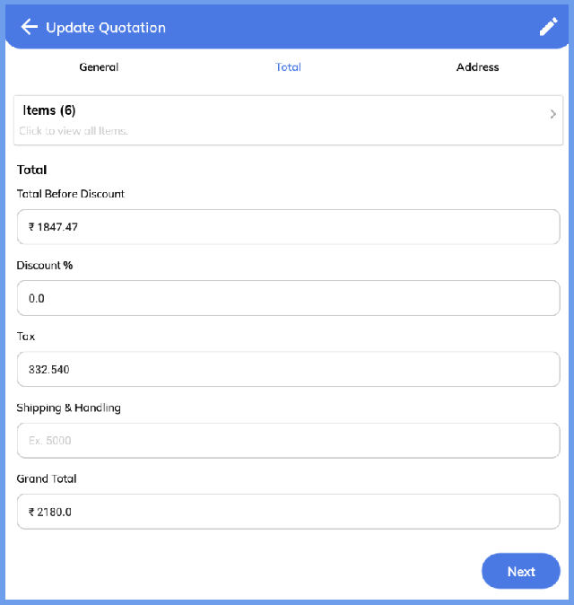

#### Creating New Quotation:

From the landing page of the Quotation section click on the “+” icon in the upper right corner.

This will open up a Quotation creation form, fill in the necessary details to create a new Quotation.

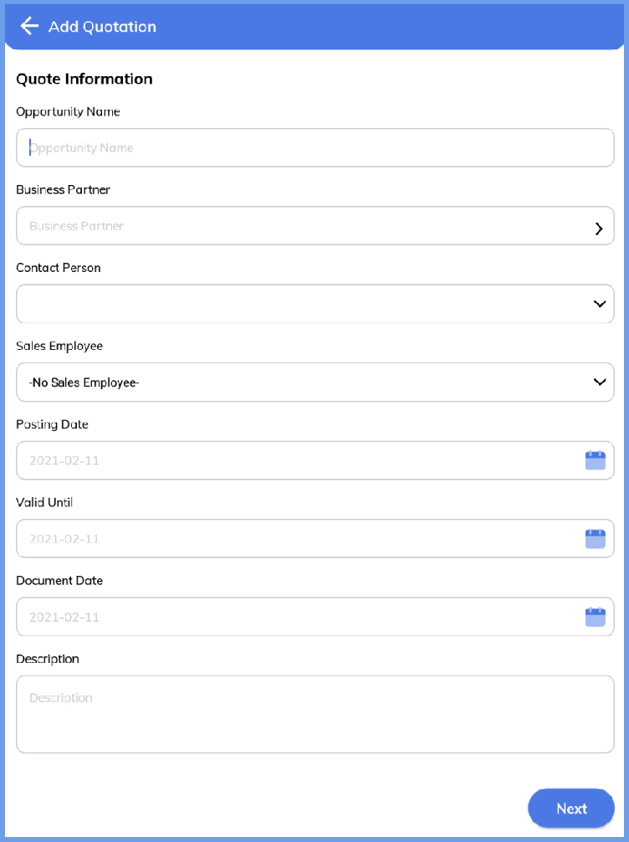

## Orders

After clicking on the Orders icon on the dashboard, it will open the existing Orders.

The Orders section is divided in 2 segments: ‘Open’, ‘All’.

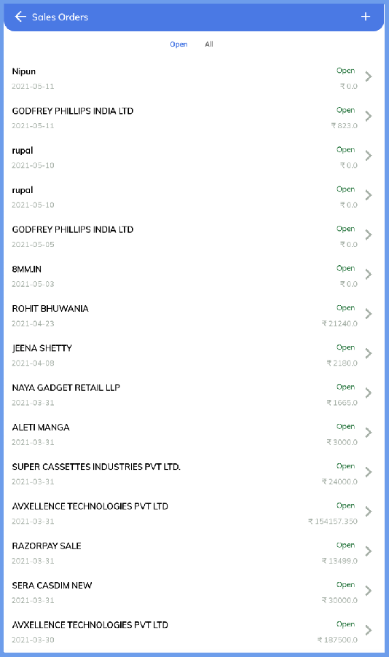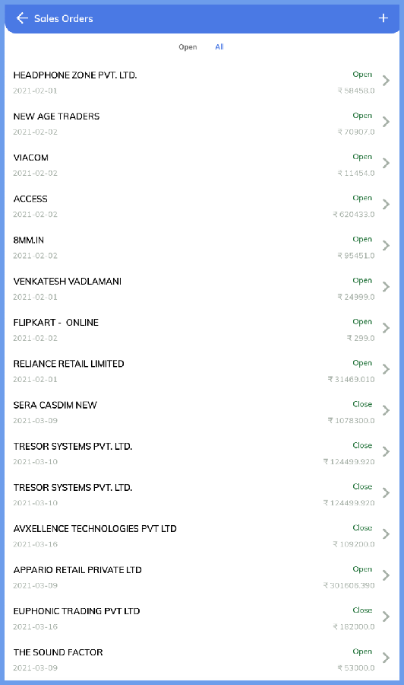

#### View Orders

Select any specific Orders to get more details of the Orders.

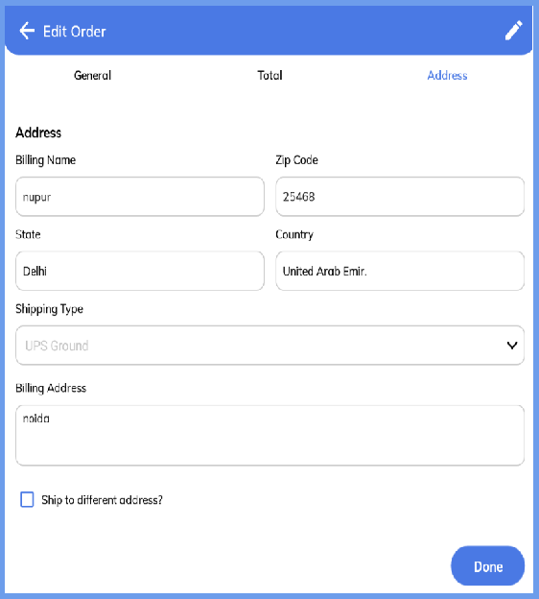Any details can be updated in the Orders by clicking on the pencil icon in the upper right corner.

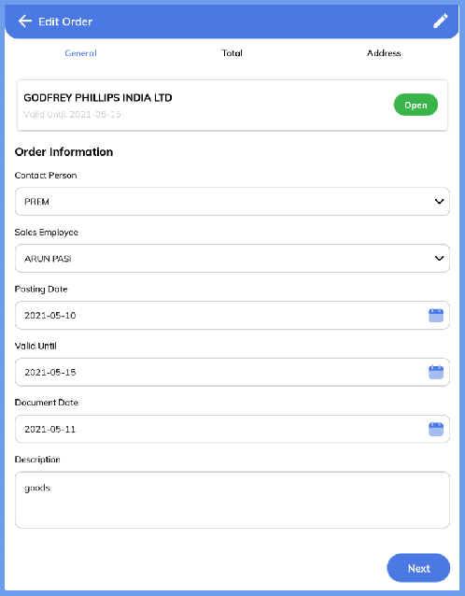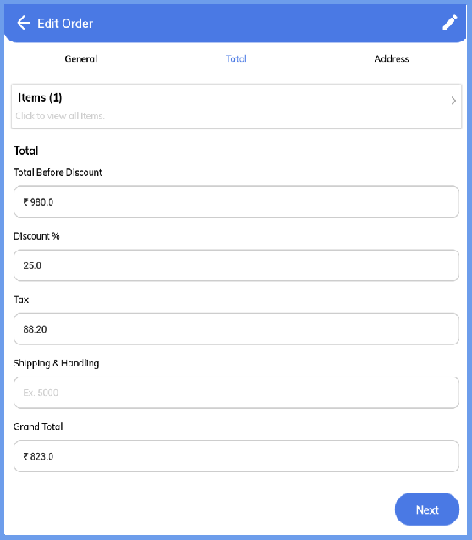

#### Creating New Orders:

From the landing page of the Orders section click on the “+” icon in the upper right corner.

This will open up an Orders creation form, fill in the necessary details to create a new Orders.

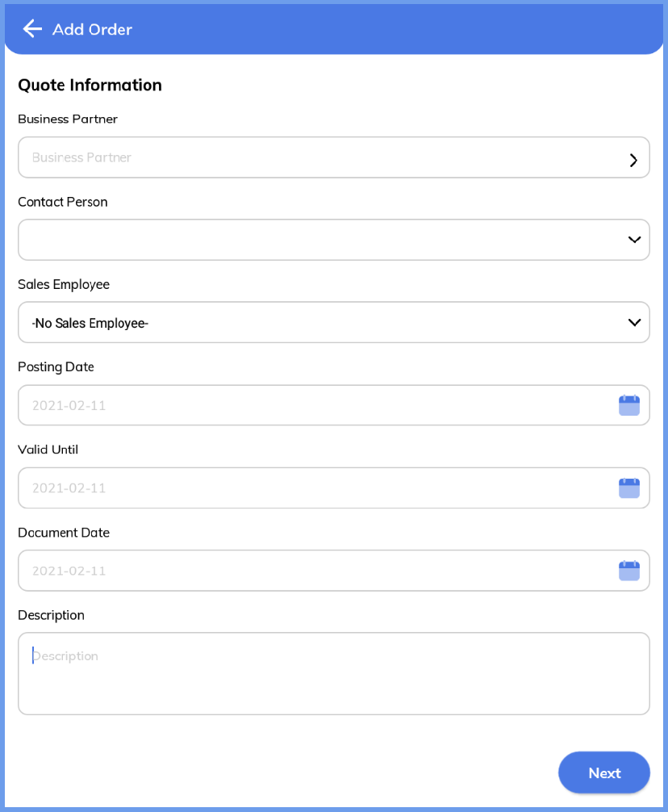

## Invoices

After clicking on the Invoice icon on the dashboard, it will open the existing Invoices.

The Invoices section is divided in 2 segments: ‘Overdue’, ‘All’.

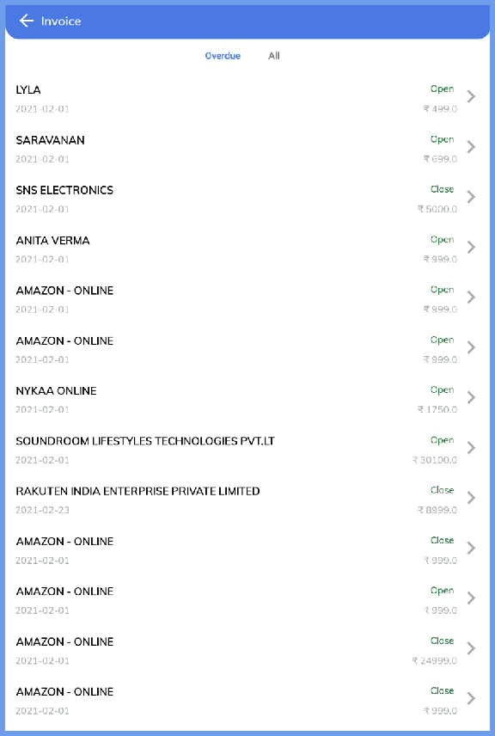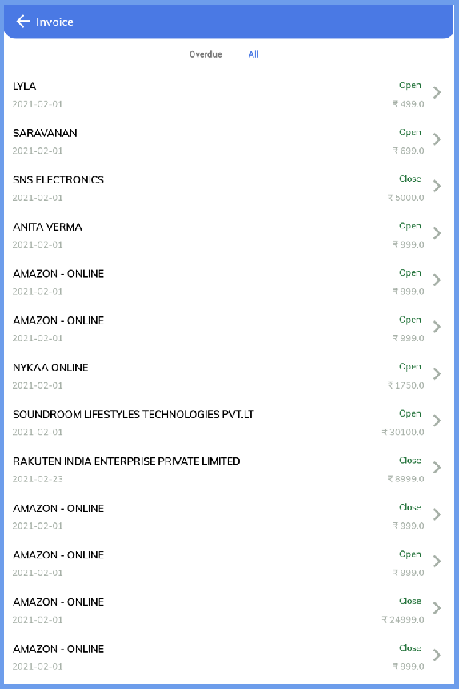

#### View Invoice

Select any specific Invoice to get more details of the Invoice.

The invoice can be downloaded from the download icon in the upper right corner.

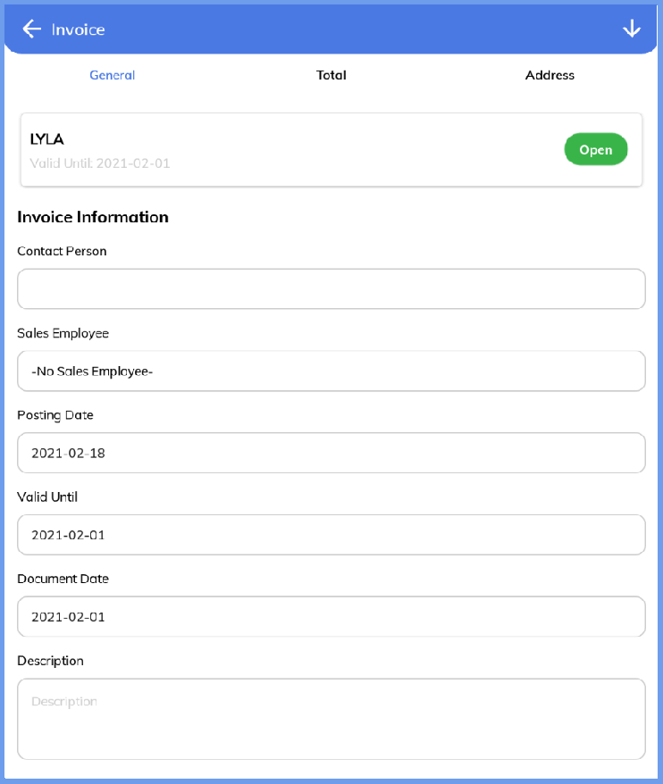

#### Share Invoice

After downloading the invoice in the previous step click on the share icon to share the invoice.

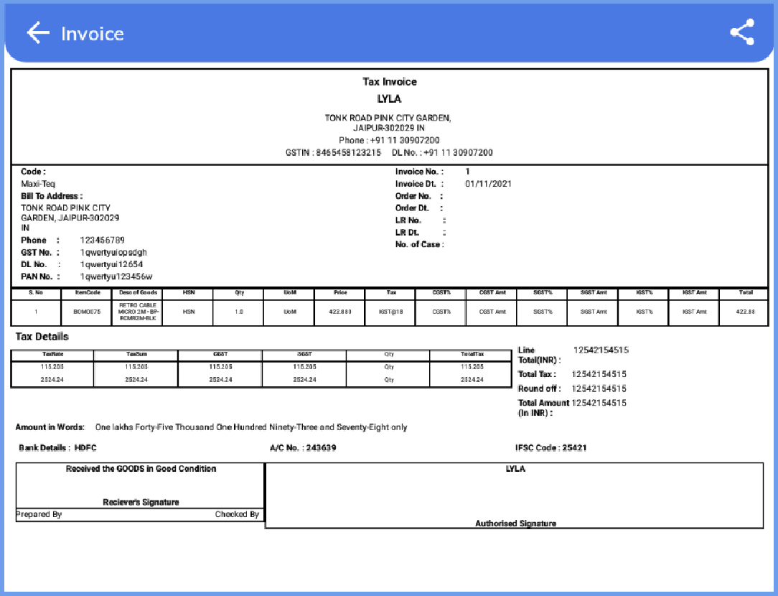

## Inventory

Track your Inventory and get the details about the items based upon the their respective categories:

* Fast Moving Items: Click on the respective icon from the Dashboard, the list of all Fast Moving Items will open.
* Slow Moving Items: Click on the respective icon from the Dashboard, the list of all Slow Moving Items will open.
* Non-Moving Items: Click on the respective icon from the Dashboard, the list of all Non Moving Items will open.
* See All Items: Click the See All text to see all the items of the inventory.

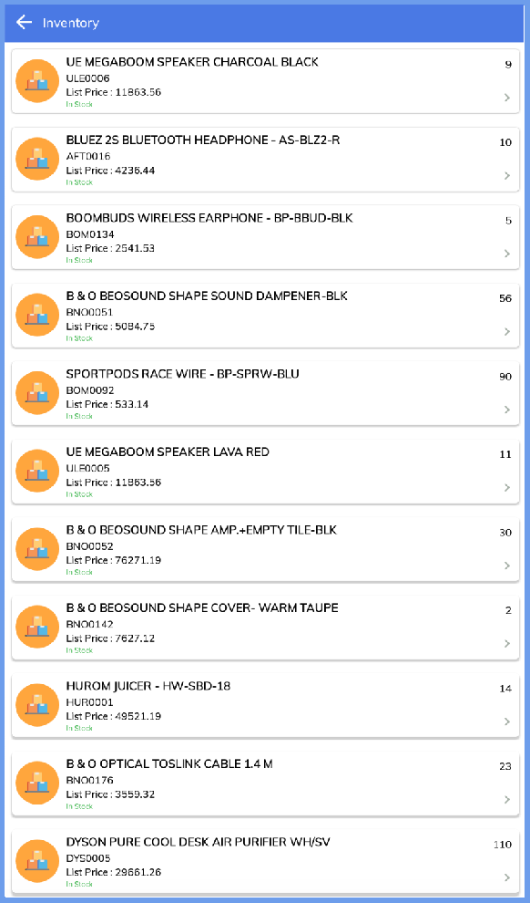 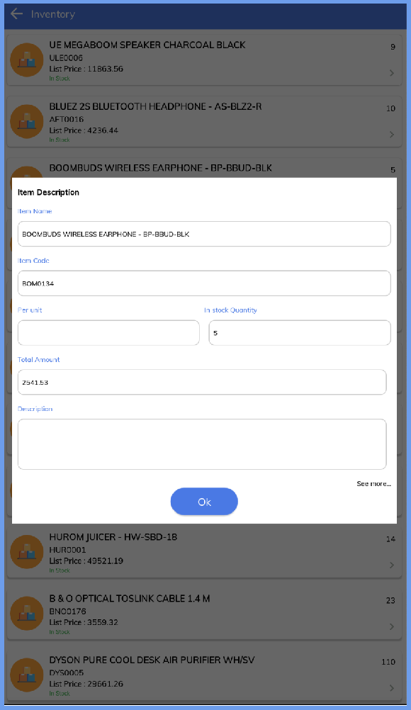

## Delivery

Delivery section is divided into 3 segments: ‘Overdue Deliveries’ ‘Open Deliveries’ ‘Closed Deliveries’ Track the status of the Deliveries and get various delivery related insights after clicking on the different sections of Delivery segments.

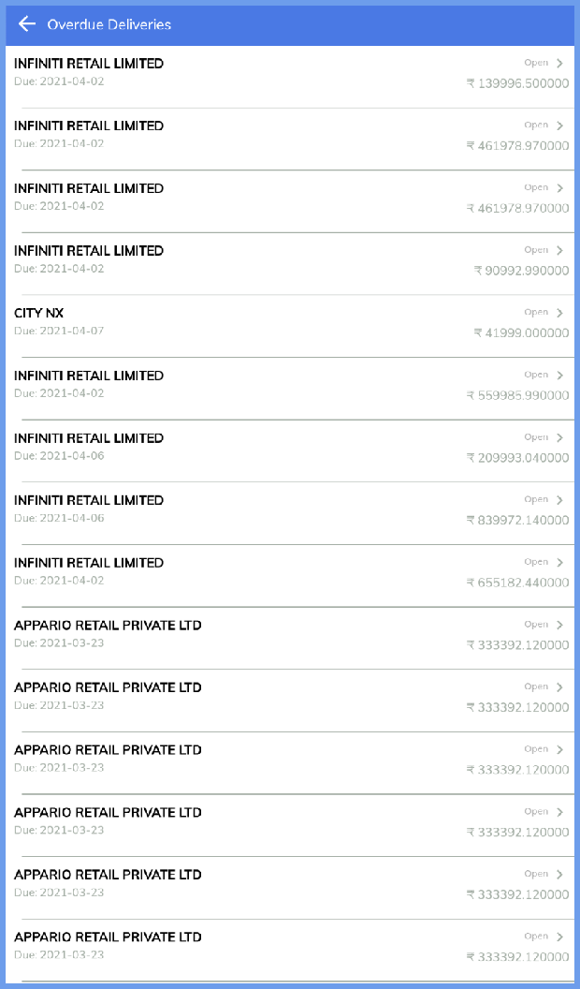

## Analytics:

The analytics section helps you to understand your performance, your business as well as enables one to make critical decisions from anywhere. Get what you need to close deals fasters with your business metrics by navigating to the Analytics section. You can navigate to the Analytics section by clicking on the Analytics icon in the bottom navigation panel.

* Sales Forecasting
* Actual Collection vs Current Projection
* Best Selling Products
* Customers with highest Sales Amount
* Better understand your inventory
* 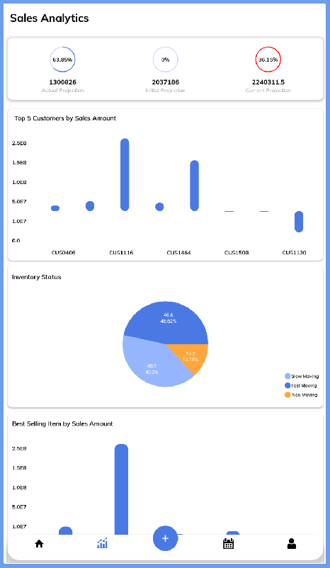Insight into deliveries

## Calendar

Manage your events and daily tasks with the Calendar and get notified about the tasks. This will help you plan well in advance for the events happening.

Navigate to the calendar from the bottom navigation panel. The calendar section has 3 segments: ‘All’, ‘Events’, ‘Tasks’

* Schedule your Events and Tasks for the day
  + Repeat your Events
  + Set your Location
* Invite your Guests for the events
* Integrated with other Calendar based System
* Attach your Documents relevant to the Meeting
* Checkbox to complete once the event is completed

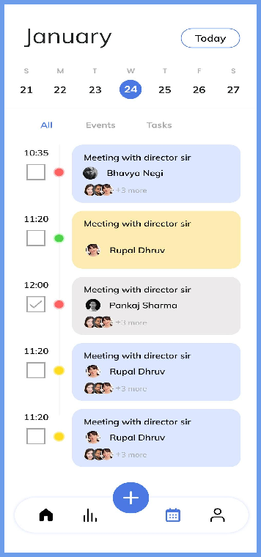

### Events

Get the list of all Events scheduled of the day in this section.

The tasks can be marked completed by ticking the checkbox in front of the Event.

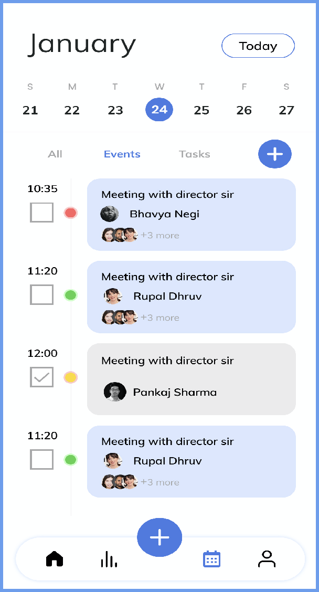

#### Creating New Events

Upon clicking the ‘+’ icon from the Events panel, it will open the Event creation form, where new Events can be created upon providing the necessary details.

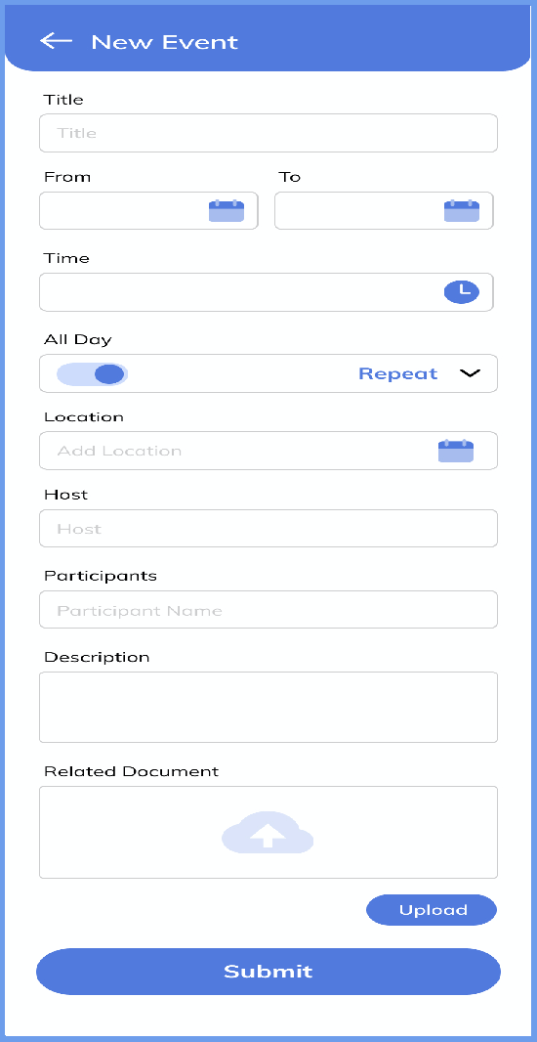

### Tasks

Get the list of all Tasks scheduled of the day in this section.

The Tasks can be marked completed by ticking the checkbox in front of the Tasks.

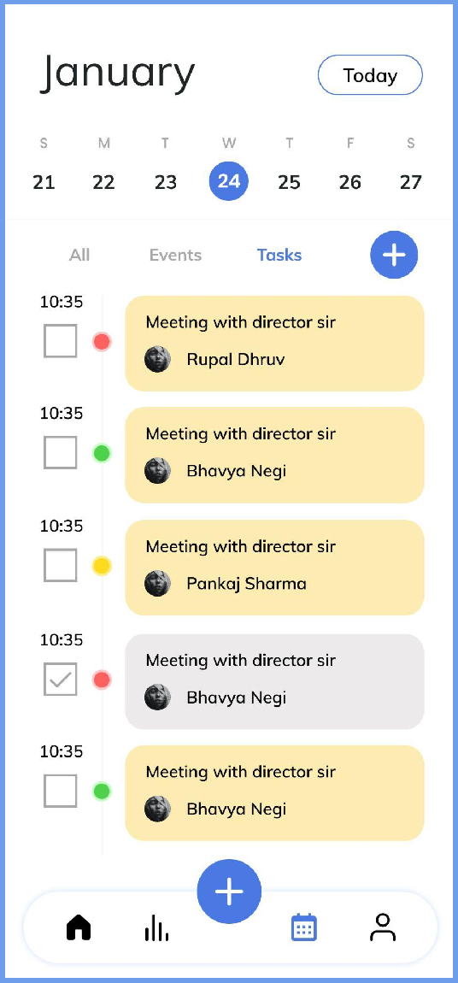

#### Creating New Tasks

Upon clicking the ‘+’ icon from the Tasks panel, it will open the Tasks creation form, where new Tasks can be created upon providing the necessary details.

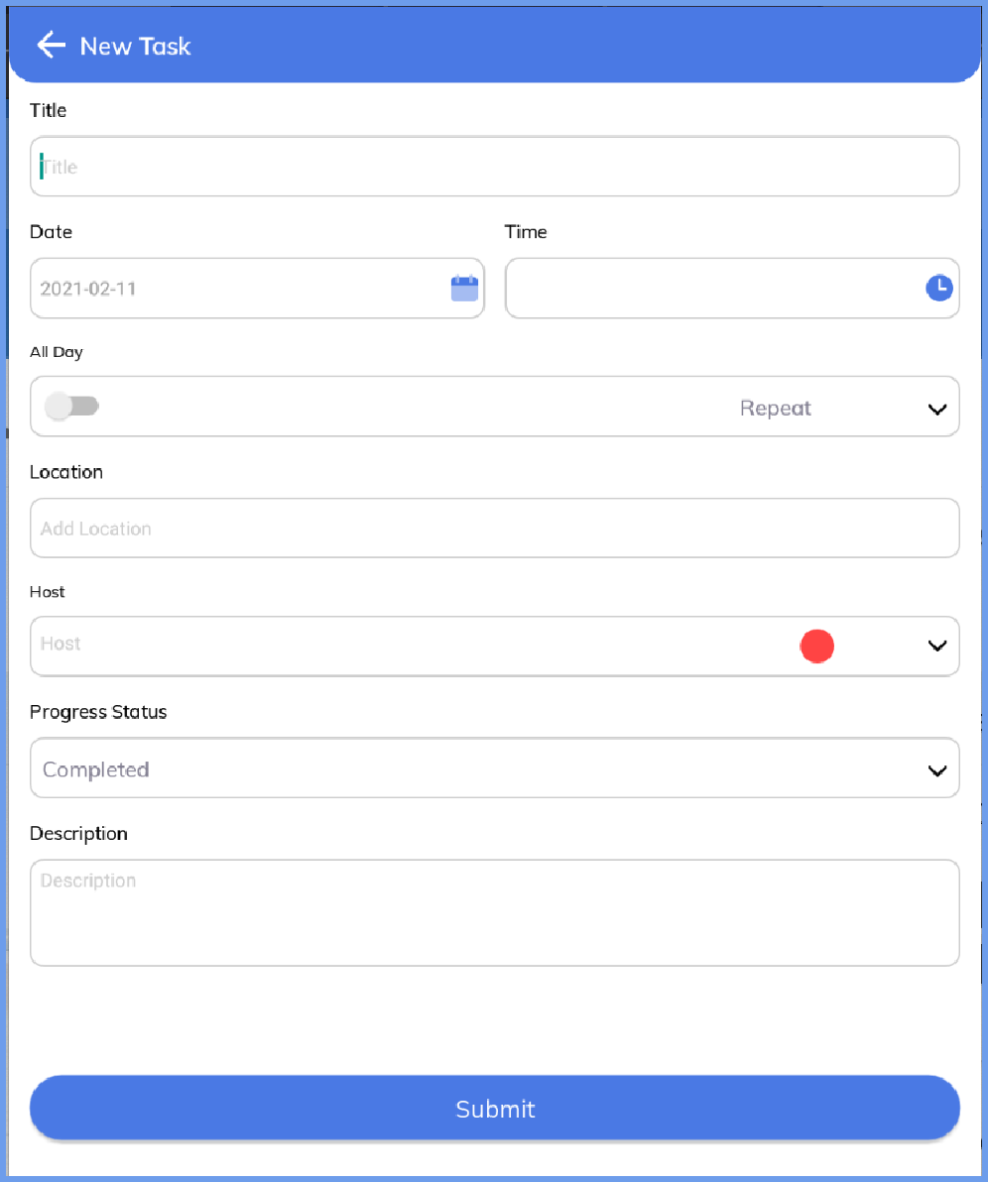

## Profile

Navigate to the Profile section by clicking Profile icon from bottom navigation panel. With details of your profile and app settings this section provides your details on the go.

* Profile
* Log-out
* Reset App
* Settings
* Submit Feedback
* About Cinntra and other Apps

